**Innovation for Energy-Efficient Restroom Light System**

The Energy-Efficient Restroom Light System is a cutting-edge technology designed to reduce energy consumption in public restrooms. This system leverages advanced sensors and lighting controls to optimize energy use while maintaining a comfortable and safe environment for users. This article provides a comprehensive overview of this innovative technology, including its design, implementation, and benefits.

To bring the innovative energy-efficient restroom light system to market, potential partnerships and collaborations can be explored with companies and organizations that share a similar vision for sustainable and eco-friendly solutions. Some potential partners include:

* Eco-friendly building and construction companies
* Sustainable energy companies and utilities
* Green technology startups and acceleration

### Challenges with Traditional Restroom Lighting

Traditional restroom lighting systems are often inefficient and wasteful, using up too much energy and raising electricity bills. Additionally, these systems require frequent maintenance and replacement, adding to the overall cost of operation.

### Our Innovative Solution

Our energy-efficient restroom lighting system is designed to address these challenges. By utilizing advanced LED technology and motion sensors, our system reduces energy consumption and minimizes waste. It also requires less maintenance and has a longer lifespan than traditional lighting systems.

### Benefits of Our System

Our energy-efficient restroom lighting system offers numerous benefits, including reduced energy costs, lower maintenance requirements, and longer lifespan. It also provides a more comfortable and convenient experience for restroom users, with automatic on/off functionality and adjustable brightness levels.

### Technical Specifications

Our energy-efficient restroom lighting system is designed to meet the highest technical standards. It features advanced LED technology, motion sensors, and adjustable brightness levels. It is also easy to install and compatible with a wide range of restroom configurations.

### Next Steps

If you are interested in learning more about our energy-efficient restroom lighting system and how it can benefit your organization, please contact us to schedule a consultation. We would be happy to answer any questions you may have and provide you with a customized quote.

### High Energy Consumption

Traditional restroom lighting systems consume a significant amount of energy, resulting in high electricity bills for businesses and organizations.

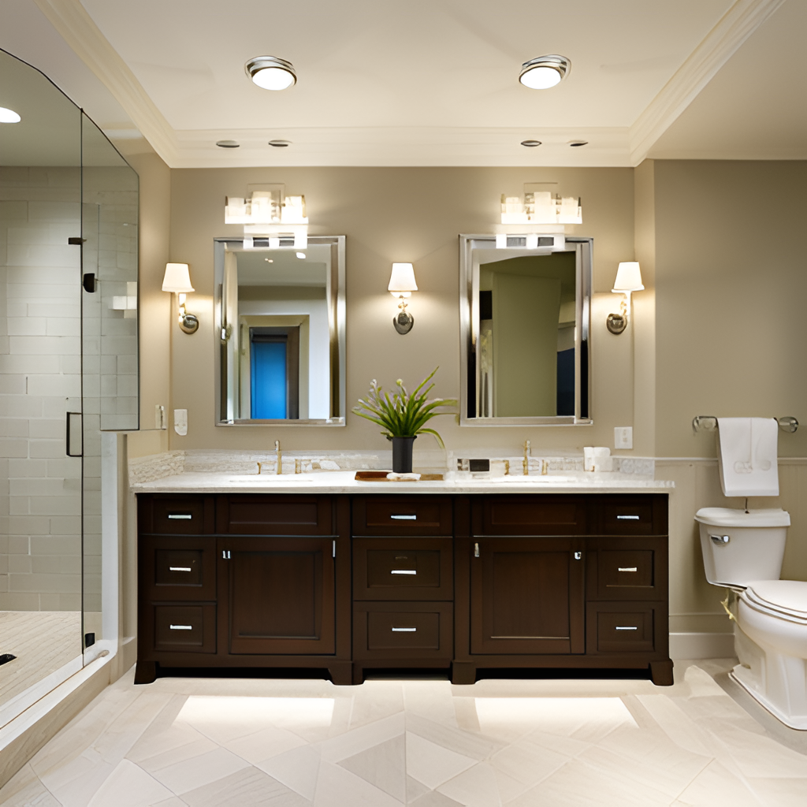

### Low Efficiency

Traditional lighting systems are often inefficient, with light being wasted in areas where it is not needed. This can lead to a lack of visibility in important areas such as mirrors and sinks.

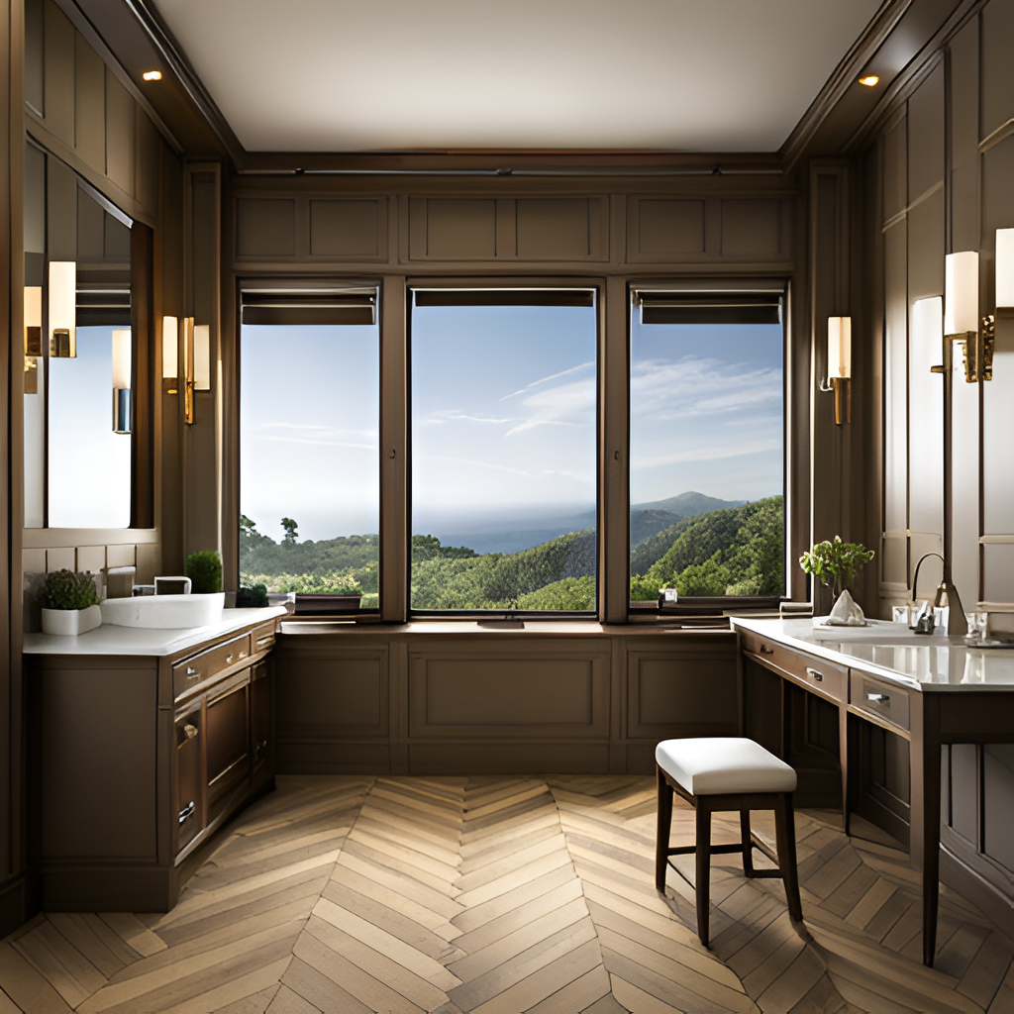

Benefits of Our System:

### Energy Savings

Our energy-efficient lighting system can save up to 70% on energy costs compared to traditional restroom lighting.

### Improved Comfort

Our system provides a comfortable and well-lit environment for restroom users, improving their overall experience.

### Lower Maintenance Costs

Our long-lasting LED lights require less maintenance and replacement, reducing overall maintenance costs.